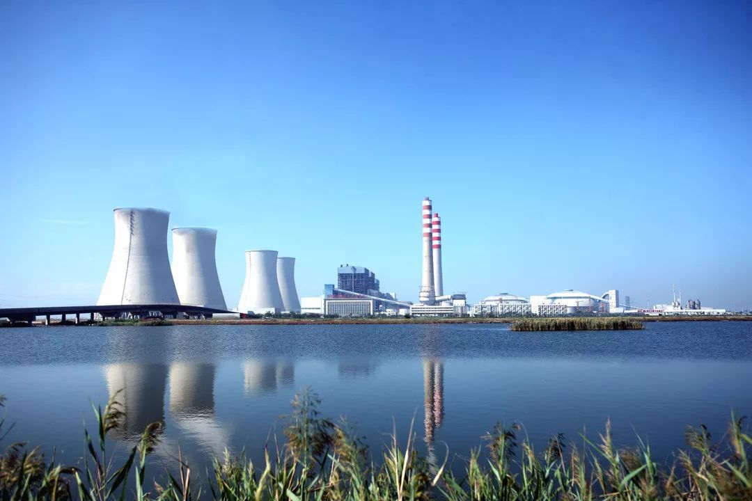美国盖姆斯德蝶阀 ***GUMUSED***

盖米斯德中线型蝶阀-**D480**系列产品技术手册

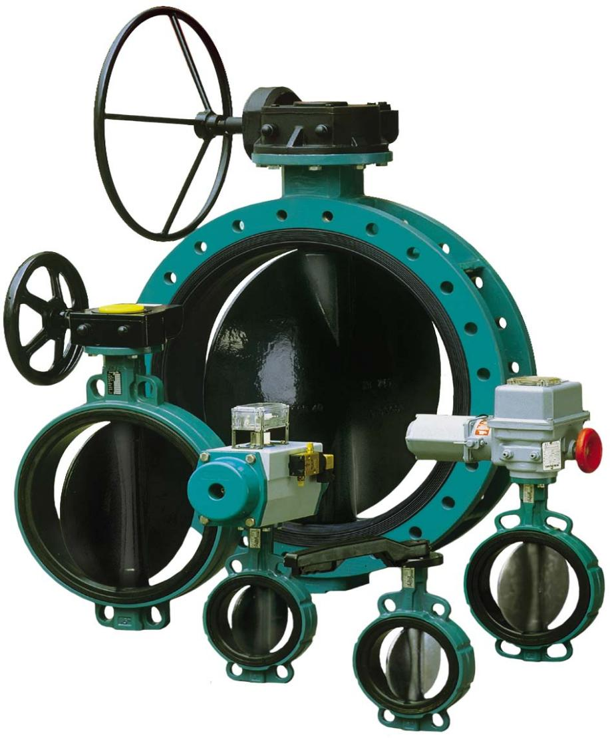Center Line Type Butterfly Valve-D480 Product Brochures

富有创造性的尖端科技

美国盖米斯德公司是以生产高质、先进的阀门、测量及控 制系统而享誉全球的企业。

自创建以来，公司逐渐发展成为一家在各大洲 都拥有生产企业、子公司以及销售公司

的国际性集团 公司。 盖米斯德阀门在广泛的工业领域中为您提供各类控制解决方 案，

例如在：

● 石化、化工行业

 ● 电厂水处理行业

● 钢铁冶金行业

● 生物制药、食品饮料行业

● 轻工机械行业

● 微电子半导体行业

盖米斯德 阀门技术和仪器的最佳选择 拥有先进的生产设备，训练有素的员工队伍，

并 且可以通过全世界范围内的子公司和分销商网络为您 提供最优质的服务，我们

不断地致力于产品完善和新 产品开发。因此我们能够不断地提供面向应用领域的

技术解决方案

1651910557(1)

|  |  |
| --- | --- |
| **1652931104(1)** |  |
| DN 25 - 400  **D480**  通径 **DN25-3000**  特性:   |  |  |  |  | | --- | --- | --- | --- | | **DESPONIA** | 中心型衬胶蝶阀 | | | | 应用领域 | 控制工业用的液体和气体,如生物制药,电力,冶金,化工,水处理,建筑行业等 | | | | 阀体构造 | D1对夹式法兰 DN 25-700 | D3LUG 凹凸端式阀体 DN 25-400 | D4 U-多孔双面式阀体 DN 150-3000 | | 安装长度 | ISO 5752/20, DIN 3202/3 K1 | | | | 上端法兰 | ISO 5211 | | | | 最大工作压力 | 10/16 bar | | | | 连接标准 | PN6, PN10, PN16, ANSI cl. 150 | | | | 温度范围 | 内衬为EPDM时 -10°C 至 95°C , 根据材料不同,最大温度范围为-40°C 至 200°C | | | | 液压测试 | ISO 5208 / DIN 3230, 密封性测试1.1 x PN, 阀体耐压测试1.5 x PN | | | |  | 蝶阀DESPONIA 在压力设备安全要求上符合  以下安全规定:PED 97/23/EG 附件1 流体第1 和第2组. | | |   结构:     |  |  | | --- | --- | |  | 阀体 (较高的阀颈部分隔离性好) | |  | 带位置显示的不锈钢阀杆 | |  | 蝶板 | |  | 可更换的带密封凹槽的密封圈 | |  | 阀杆轴套: DN2-400 为Rilsan材质, DN450-1200为青铜材质 | |  | 方形蝶板转轴 | |  | 外部阀杆密封 | |  | 防护垫圈(固定用) |   DN 450 - 3000 | |
| 3 DESPONIA | |

|  |  |
| --- | --- |
|  | **1652931104(1)** |
| **D480** 通径**:** **25-3000** | |
| 订购代码:**D480** **0100** **. 3 3** **-** **G40R** **.** **4A** **.G4CP** **.** **E**  **D3** 或**D4** (D4 只有 PN10/16 )  **2A** (GGG40)  流体  DN25-200 DN250-600 DN700-3000  压力和温度的选择因工作环境而变化。  10 bar  6 bar 2,5 bar   |  |  |  |  |  |  |  |  |  |  |  |  |  |  |  |  |  |  |  |  |  |  |  | | --- | --- | --- | --- | --- | --- | --- | --- | --- | --- | --- | --- | --- | --- | --- | --- | --- | --- | --- | --- | --- | --- | --- | | 阀体材料 **DN** | 25 | 32 | 40 | 50 | 65 | 80 | 100 | 125 | 150 | 200 | 250 | 300 | 350 | 400 | 450 | 500 | 600 | 700 | 800 | 900 | 1000 | 1200 | | **GG25** **(1A)** 10 bar |  |  |  |  |  |  |  |  |  |  |  |  |  |  |  |  | **2** |  |  |  |  |  | | 10 bar  16 bar |  |  |  |  |  |  |  |  |  |  |  | **2** |  |  |  |  |  |  |  |  |  |  | |  |  |  |  |  |  |  |  | **3** |  |  |  |  |  |  |  |  |  |  |  |  |  |   **GGG40** **(2A)**  å ç éè ê ë í ì  **D1** 对夹式法兰  **D4** U 多孔双面式阀体  ç 通径  **0025-1200** **mm** é 工作压力   见下表  è 公称压力等级  **\*\***  PN6/ 10/ 16 见下表   |  |  |  |  | | --- | --- | --- | --- | | ê 阀体材质 | **G25R** 铸铁 GG25, Rilsan尼龙涂层 250µ | | | | **G25E** 铸铁 GG25, 环氧树脂涂层70µ | | | | **G40R** 球墨铸铁GGG40, Rilsan尼龙涂层 250µ DN25-400 | | | | **G40E** 球墨铸铁GGG40, 环氧树脂涂层 70µ | | | | ë 阀杆材质 | **4A** | 不锈钢1.4028, | AISI420 | | **4B** | 不锈钢1.4401, | AISI316 |   **G40R** 球墨铸铁GGG40, Rilsan尼龙涂层 250µ (max 90°C) DN25-700   |  |  | | --- | --- | | **G40E** 球墨铸铁GGG40, 环氧树脂涂层 70µ |  | | **2AC** 球墨铸铁GGG40, 镀铬(最大工压为10bar) | | | **4C0** 不锈钢1.4408, AISI316 | | | **4CP** 不锈钢1.4408, AISI316, 抛光 | | | **4CH** 不锈钢1.4408, AISI316, Halar 涂层min.600µ | | | **4D0** Uranus B6 | | | **5C0** Alubronze G-Cu Al 10 Fe 铝铜合金 | |   **7H0** Hastelloy C 哈式合金    **E** EPDM (max.95°C) **N** 腈橡胶 **B** Butyl **SV** 蒸汽用硅胶   |  |  |  |  |  |  |  |  | | --- | --- | --- | --- | --- | --- | --- | --- | | **EC** | EPDM (max 130°C) | **NC** | 羧肽酶腈(耐磨) | **H** | Hypalon | **SA** | 食品饮料用硅橡胶 | | **EW** | EPDM (KTW) | **RN** | 天然橡胶 | **S** | 硅橡胶 | **V** | Viton 氟橡胶 |   根据具体情况,可提供其它密封材料  å 阀门类型  **D3** LUG凹凸端式阀体  ì 密封圈材料  í 蝶板材质  DN450-1200  DN450-3000  DN250-400  DN800  3000  **\*** 工作压力 (代码 )    **DESPONIA**  **3**  **D1**  PN16  PN10  **D3**  PN16  PN10  **D4**  PN16  **Other** **executions** **on** **request** **!**  **DN→**  PN6  PN10  **2**  **2**  **2**  **3**  **3**  **3**  **3**  **3**  **3**  安装阀门时请注意:  - 阀门类型  - 阀体材料  - 介质  - 最大工作压力  - 无水锤 | |
| DESPONIA 4 | |

|  |  |
| --- | --- |
| **1652931104(1)** |  |
| **D480**  通径**:** **25-3000**  **Kv** 流量值**m3/h**   |  |  |  |  |  |  |  |  |  |  |  | | --- | --- | --- | --- | --- | --- | --- | --- | --- | --- | --- | | 25/32 | 40 | 50 | 65 | 80 | 100 | 125 | 150 | 200 | 250 | 300 | | 40 | 50 | 100 | 210 | 360 | 650 | 1050 | 1770 | 3400 | 5090 | 7360 |  |  |  |  |  |  |  |  |  | | --- | --- | --- | --- | --- | --- | --- | --- | |  |  |  |  |  |  |  |  |   350 400 450 500 600 700 800 900 1000 1200  9800 12900 16800 21700 29800 35100 45900 59300 82100 102700  **DN**  **kv**  **D1** 对夹式阀体尺寸图**,** **DN** **25-700**  **DN** **125/150/200**  **DN** **25/32**  **DN** **80/100**  **DN** **40/50/65**  1651915251(1)  1651915477(1)  *当使用塑料的阀杆衬套时，请注意检查H的尺寸. | |
| 5 DESPONIA | |

|  |  |
| --- | --- |
|  | **1652931104(1)** |
| 上端法兰连接标准**:** **ISO** **5211**  **D480** 通径**:** **25-1200**  **D3** **LUG,** 凹凸端式阀体 **DN** **25-400**     |  |  |  |  |  |  |  |  | | --- | --- | --- | --- | --- | --- | --- | --- | | **DN** | A | B3 | C | D3 | E | H**\*** | [kg] | | **25/32** | 110 | 50 | 30 | 72 | 19 | 17,0 | 1,4 | | **40** | 130 | 60 | 33 | 86 | 19 | 27,0 | 2,0 | | **50** | 135 | 72 | 43 | 117 | 19 | 30,0 | 3,2 | | **65** | 150 | 82 | 46 | 130 | 19 | 49,0 | 4,0 | | **80** | 160 | 88 | 46 | 188 | 19 | 68,5 | 6,1 | | **100** | 180 | 102 | 52 | 219 | 19 | 88,5 | 8,5 | | **125** | 195 | 116 | 56 | 248 | 19 | 114,5 | 10,0 | | **150** | 210 | 128 | 56 | 274 | 19 | 142,0 | 11,0 | | **200** | 240 | 161 | 60 | 332 | 25 | 193,5 | 19,6 | | **250** | 280 | 199 | 68 | 402 | 32 | 243,5 | 28,7 | | **300** | 315 | 234 | 78 | 472 | 32 | 292,5 | 41,2 | | **350** | 330 | 258 | 78 | 520 | 40 | 329,5 | 55,0 | | **400** | 365 | 290 | 102 | 584 | 40 | 375,5 | 75,0 |   **D4** **U,** 多孔双面式阀体 **DN** **150-3000**  1651935440(1)  1651935509(1)  1651935654(1) | |
| DESPONIA 6 | |

|  |  |  |  |  |  |  |
| --- | --- | --- | --- | --- | --- | --- |
| **1652931104(1)** | | | | | |  |
| **D480** 通径**:** **DN25-1200** | | | | | | |
| 手柄 **(DN25-300):** | | | | 铝合金手柄, 环氧树酯涂层   |  |  |  |  |  |  | | --- | --- | --- | --- | --- | --- | | DN |  | A | B | C | (kg) | | 25-40 | **HLA.F0708.180** | 180 | 45,5 | 41 | 0,4 | | 50-65 | **HLA.F0711.180** | 180 | 45,5 | 41 | 0,4 | | 80-100 | **HLA.F0711.240** | 243 | 45,5 | 43 | 0,5 | | 125-150 | **HLA.F0714.340** | 340 | 45,5 | 51 | 0,6 | | 200 | **HLA.F0717.340** | 340 | 45,5 | 51 | 0,6 | | 250-300 | **HLA.F1222.500** | 500 | 77,5 | 40 | 2,2 |   聚酰胺 P 6, 加 30% 玻璃纤维加固   |  |  |  |  |  |  | | --- | --- | --- | --- | --- | --- | | DN |  | A | B | C | (kg) | | 25-40 | **HLP.F0708.240** | 243 | 45,5 | 41 | 0,3 | | 50-65 | **HLP.F0711.240** | 243 | 45,5 | 41 | 0,3 | | 80-100 | **HLP.F0711.240** | 243 | 45,5 | 43 | 0,3 | | 125-150 | **HLP.F0714.340** | 340 | 45,5 | 51 | 0,5 | | 200 | **HLP.F0717.340** | 340 | 45,5 | 51 | 0,5 | | | |
| 方形接口 **:** **(DN25-200)** 手轮**:** **(DN25-150)** | | | | | | |
|  | | |  |  |  |  | | --- | --- | --- | --- | | DN |  | G | H | | 25-40 | **PO.F0708.30** | 30 | 65 | | 50-100 | **PO.F0711.30** | 30 | 65 | | 125-150 | **PO.F0714.30** | 30 | 65 | | 200 | **PO.F0717.30** | 30 | 65 | | |  | |  |  |  |  | | --- | --- | --- | --- | | DN |  | I | J | | 25-40 | **HW.F0708.200** | 200 | 52 | | 50-100 | **HW.F0711.200** | 200 | 52 | | 125-150 | **HW.F0714.250** | 250 | 52 | | |
| 带齿轮箱的手轮: | | | ø  n  **pmax** **DN25-600** **...16** **bar,** **DN700-1200** **...** **10** **bar**   |  |  |  |  |  |  |  |  |  |  |  | | --- | --- | --- | --- | --- | --- | --- | --- | --- | --- | --- | | DN |  | A | B | C | D | E | H | R | **\*** | (kg) | | 25-40 | **GB232-05.F0708.100** | 80 | 110,5 | 42,5 | 44,5 | 108 | 46 | 100 | 10 | 0,8 | | 50- 100 | **GB232-05.F0711.100** | 80 | 110,5 | 42,5 | 44,5 | 108 | 46 | 100 | 10 | 0,8 | | 125 | **GB232-05.F0714.100** | 80 | 110,5 | 42,5 | 44,5 | 108 | 46 | 100 | 10 | 0,8 | | 150 | **GB232-07.F0714.160** | 100 | 133 | 50 | 58 | 127 | 58 | 160 | 9,25 | 1,8 | | 200 | **GB232-07.F0717.160** | 100 | 133 | 50 | 58 | 127 | 58 | 160 | 9,25 | 1,8 | | 250 | **GB232-10.F1222.250** | 146 | 177,5 | 60 | 82,5 | 201 | 73 | 250 | 11,25 | 3,3 | | 300 | **GB232-10.F1222.250** | 146 | 177,5 | 60 | 82,5 | 201 | 73 | 250 | 11,25 | 3,3 | | 350 | **GB232-12.F1222.315** | 175 | 218 | 80 | 91 | 279 | 88 | 315 | 10 | 7 | | 400 | **GB232-12.F1227.315** | 175 | 218 | 80 | 91 | 279 | 88 | 315 | 10 | 7 | | 450 | **GB1250N.F1445.400** | 220 | 258 | 104,5 | 110 | 310 | 102 | 400 | 13,75 | 22 | | 500 | **GB1250N.F1445.400** | 220 | 258 | 104,5 | 110 | 310 | 102 | 400 | 13,75 | 22 | | 600 | **GB1950N/SP4.F1670.500** | 285 | 402,5 | 211 | 142,5 | 435 | 155 | 500 | 52 | 45 | | 700 | **GB1950N/SP4.F2570.500** | 285 | 402,5 | 211 | 142,5 | 435 | 155 | 500 | 52 | 45 | | 800 | **GB1950N/SP4.F2570.500** | 285 | 402,5 | 211 | 142,5 | 435 | 155 | 500 | 52 | 45 | | 900 | **GB6800N/SP4.F3080.600** | 370 | 482 | 263 | 170 | 468 | 159 | 600 | 79,25 | 70 | | 1000 | **GB6800N/SP4.F3080.600** | 370 | 482 | 263 | 170 | 468 | 159 | 600 | 79,25 | 70 | | 1200 | **GBA250/SP9.F30100.800** | 510 | 725 | 431 | 235 | 599 | 175 | 800 | 176 | 225 |   * n = 手轮开闭 | | | |
| 材料:  GB232  GB880 - GBA250 | : 铝合金,聚亚安酯涂层 : 铸铁, 聚亚安酯涂层 | |
| 7 DESPONIA | | | | | | |

|  |  |  |
| --- | --- | --- |
|  | **1652931104(1)** | |
| **D480** 通径**:** **DN25-1200**  安装步骤：  1、管道上的法兰必须对正，以便于阀门的安装。蝶板应处于部分开启的状态。  2 、在蝶板微开的状态下装上螺栓，但不要拧紧螺母。  3、将蝶板完全打开，并确保管道平行排列。均匀地拧螺母直到法兰盘与阀体完全固定。 切勿使用衬垫或油脂。当阀门已安装完毕，切勿焊接法兰盘。 | | |
|  | | |
| 流量(m3/h)  压损(bar)  表2  流速 | | 水压测试特性表：  Kv流量值见表1  压损和流量见表2  表1   |  |  |  |  |  |  |  |  |  |  | | --- | --- | --- | --- | --- | --- | --- | --- | --- | --- | | DN | 开启角度 | | | | | | | | | | 10° | 20° | 30° | 40° | 50° | 60° | 70° | 80° | 90° | | 25/32 | 0,4 | 1,7 | 4,3 | 6,9 | 11 | 17 | 29 | 46 | 52 | | 40 | 0,8 | 2,6 | 7,3 | 15 | 24 | 38 | 63 | 87 | 120 | | 50 | 1,3 | 3,8 | 10 | 22 | 38 | 58 | 98 | 128 | 189 | | 65 | 2,1 | 7,3 | 18 | 35 | 61 | 93 | 185 | 236 | 311 | | 80 | 2,7 | 10 | 26 | 48 | 85 | 128 | 218 | 344 | 433 | | 100 | 4,3 | 15 | 41 | 74 | 123 | 227 | 372 | 624 | 745 | | 125 | 6,4 | 24 | 60 | 116 | 213 | 386 | 587 | 1018 | 1219 | | 150 | 10 | 39 | 93 | 169 | 316 | 526 | 847 | 1223 | 1805 | | 200 | 19 | 64 | 163 | 302 | 567 | 985 | 1551 | 2288 | 3093 | | 250 | 28 | 103 | 249 | 457 | 848 | 1482 | 2285 | 3302 | 4825 | | 300 | 34 | 127 | 308 | 605 | 1119 | 2091 | 3196 | 4912 | 6946 | | 350 | 47 | 163 | 388 | 791 | 1490 | 2557 | 3956 | 5715 | 8269 | | 400 | 60 | 223 | 490 | 1037 | 1900 | 3256 | 5187 | 7800 | 11036 | | 450 | 77 | 266 | 644 | 1253 | 2400 | 4070 | 6565 | 9824 | 14115 | | 500 | 99 | 334 | 827 | 1629 | 2973 | 5150 | 8198 | 12625 | 18056 | | 600 | 137 | 488 | 1137 | 2356 | 4404 | 7456 | 11780 | 17837 | 24868 | | 700 | 187 | 643 | 1632 | 3142 | 5837 | 10387 | 16997 | 24552 | 35883 | | 800 | 249 | 943 | 2230 | 4392 | 7977 | 13682 | 22303 | 30626 | 44559 | | 900 | 317 | 1204 | 2835 | 5634 | 10390 | 17479 | 28602 | 41229 | 58676 | | 1000 | 514 | 1935 | 4492 | 8020 | 13602 | 22115 | 36289 | 55088 | 69427 | | 1100 | 711 | 2666 | 6150 | 10406 | 16813 | 26750 | 43976 | 68946 | 80178 | | 1200 | 947 | 3552 | 7912 | 13846 | 21586 | 34486 | 56460 | 88288 | 103785 |   Kv [m3/h] |
| DESPONIA 8 | | |

|  |  |  |  |  |
| --- | --- | --- | --- | --- |
| **1652931104(1)** | | | |  |
| **D480** 蝶阀 **DN25-1200**  电动执行器 **(BERNARD):**  防护等级 IP67, ED 30%, 2 行程开关 开/关  2 力矩限位开关 (只在型号 AS..),  电机热保护开关, 1 紧急制动手轮扳(以上都为标准配置) | | | | |
|  | | | | |
| Z3 | OA | AS 18 - 80 | AS100 - 400 | |
| |  |  |  |  |  |  |  | | --- | --- | --- | --- | --- | --- | --- | | 型号 | A | B | C | D | E | (kg) | | OA3 | 193 | 134 | 183 | 93 | 234 | 6 | | OA6 | 292 | 90 | 190 | 65 | 224 | 6 | | OA8 | 292 | 90 | 190 | 65 | 224 | 7 | | OA15 | 358 | 98 | 190 | 65 | 224 | 7 | | OAP | 292 | 90 | 190 | 65 | 224 | 7 | | AS18 | 479 | 167 | 315 | 89 | 177 | 16 | | AS25 | 479 | 167 | 315 | 89 | 177 | 18 | | ASP | 507 | 167 | 315 | 89 | 177 | 18 | | | |  |  |  |  |  |  |  | | --- | --- | --- | --- | --- | --- | --- | | 型号 | A | B | C | D | E | (kg) | | AS50 | 509 | 169 | 315 | 89 | 177 | 17 | | AS80 | 509 | 169 | 315 | 89 | 208 | 18 | | AS100 | 611 | 497 | 442 | 206 | 284 | 36 | | AS200 | 754 | 566 | 442 | 109 | 281 | 68 | | AS400 | 645 | 497 | 442 | 154 | 281 | 70 | | ASM1 RS600 | 831 | 579 | 407 | 192 | 299 | 65 | | ASM3 RS1825 | 945 | 693 | 407 | 177 | 328 | 112 | | ASM2 RS1825G | 1113 | 861 | 407 | 177 | 328 | 120 | | | |
| 驱动器的选择: - 对液体最高  - 工作压力 | 80°C  16 bar (DN25- 150)  10 bar (DN200- 1200) | | | |
| |  |  |  |  | | --- | --- | --- | --- | | DN | 型号 | |  | | 25-80 | OA6-***/**-006“ | OAP-***/**-030“ (060“) | Z3-230/50-011“ | | 100 | OA6-***/**-006“ | OAP-***/**-030“ (060“) |  | | 125 | OA8-***/**-006“ | OAP-***/**-030“ (060“) |  | | 150 | OA15-***/**-015“ | ASP-***/**-030“ (060“) |  | | 200 | AS25-***/**-010“ | ASP-***/**-030“ (060“) |  | | 250 | AS50-***/**-030“ | |  | | 300 | AS50-***/**-030“ | |  | | 350 | AS80-***/**-030“ | |  | | 400 | AS200-***/**-069“ | |  | | | |  |  | | --- | --- | | DN | 型号 | | 450 | AS200-***/**-069“ | | 500 | AS200-***/**-069“ | | 600 | AS400-***/**-063“ | | 700 | ASM1 RS600-400/50-140“ | | 800 | ASM1 RS600-400/50-140“ | | 900 | ASM3 RS1825-400/50-134“ | | 1000 | ASM2 RS1825G-400/50-168“ | | 1200 | ASM2 RS1825G-400/50-168“ | | | |
| ***/** 3 相 400V50Hz 或 1 相 230V50Hz  其它电压, 开阀时间和调节型电动头,防爆电动头及附件可向盖米查询 | | | | |
| 9 DESPONIA | | | | |

|  |  |
| --- | --- |
|  | **1652931104(1)** |
| **D480-**蝶阀气动头的选型 **DN** **25** **-** **DN** **1200**  型号**:** **DR** 和 **SC** | |
| 对液体20ºC-80ºC, 控制压力Pmin:6 bar  **GEMÜ**  最大  **DR** **(** 双作用 **)**  **SC** **(** 单作用 **)**  **DN**  工作  压力  **DR0015F03F04/11A**  **SC0030-6F05/14A** **SC0030-6F05/14A** **SC0060-6F05F07/14A** **SC0060-6F05F07/14A** **SC0100-6F05F07/17A** **SC0150-6F07F10/17A** **SC0220-6F07F10/22A** **SC0300-6F07F10/22A** **SC0600-6F10F12/27A** **SC0900-6F14/36A** **SC1200-6F14/36A** **SC2000-6F16/46A** **SC3000-6F16/46A** **SC5000-4,5F25/55A** **SC5000-6F25/55A** 可询问  可询问  可询问  可询问  可询问  可询问  25/32  40  50  65  80  100  125  150  200  250  300  350  400  450  500  600  700  800  900  1000  1200  **6** **bar**  **DR0015F03F04/11A**  **DR0015F03F04/11A**  **DR0030F05/14A**  **DR0060F05F07/14A**  **DR0060F05F07/14A**  **DR0100F05F07/17A**  **DR0150F05F07/17A**  **DR0220F07F10/22A**  **DR0450F10F12/27A**  **DR0450F10F12/27A**  **DR0900F12F14/27A**  **DR1200F12F14/27A**  **DR2000F16F14/36A**  **DR3000F16/46A**  **DR3000F16/46A**  **DR5000F25/55A**  可询问  可询问  可询问  可询问   |  |  |  |  | | --- | --- | --- | --- | | **16** **bar** | 25/32  40  50  65  80  100  125  150  200 | **DR0015F03F04/11A**  **DR0015F03F04/11A**  **DR0030F05/14A**  **DR0030F05/14A**  **DR0060F05F07/14A**  **DR0060F05F07/14A**  **DR0150F05F07/17A**  **DR0150F05F07/17A**  **DR0300F07F10/22A** | **SC0030-6F05/14A**  **SC0030-6F05/14**  **SC0060-6F05F07/14A**  **SC0100-6F05F07/17A**  **SC0150-6F05F07/17A**  **SC0220-6F07F10/17A**  **SC0300-6F07F10/22A**  **SC0450-6F07F12/27A**  **SC0900-6F14/36A** | |  |  |  |  | | **10** **bar** | 250  300  350  400  450  500  600  700  800  900  1000  1200 | **DR0450F10F12/27A**  **DR0600F10F12/27A**  **DR0900F12F14/27A**  **DR1200F12F14/27A**  **DR2000F16F14/36A**  **DR3000F16/46A**  **DR5000F25/55A**  **DR5000F25/55A**  可询问  可询问  可询问 | **SC0900-6F14/36A**  **SC1200-6F14/36A**  **SC2000-6F16/46**  **SC3000-6F16/46A**  **SC5000-6F16/55**  可询问  可询问  可询问  可询问  可询问  可询问 |   常用选择**(**推荐**)** **DN25-200** **pmax** **=** **16** **bar,** **DN250** **pmax=10** **bar**  只有在选择较小的蝶板时**,**才可选择**6** **bar**控制压力 | |
| 10 | |

|  |  |
| --- | --- |
| **1652931104(1)** |  |
| DR/SC 0015-5000  ø  气动头尺寸图:   |  | | --- | | ¯ Z    驱动头 - EN 12116 4  C  H  45¡  45¡  方形口  R  h  h1  P  O  G  4  B  22.5  205  B  B  L  20  20      "X"  型号DR/SC 2000      "X"    T 接口  A  Q1  20  20  Q  DR/SC 3000/5000  型号  M6x 10  W  W1      确认中心圈/轴  I  N  "X"  D  22.5  M  C  C  230  S  M5xE  型号DR/SC 5000  型号DR/SC 3000      ¯ d  F  接口 '2'  接口 '4'  VDI/VDE 3845        M6x 12  M6x 10  M N  M  N |  |  |  |  |  |  |  |  |  |  |  |  |  |  |  |  | | --- | --- | --- | --- | --- | --- | --- | --- | --- | --- | --- | --- | --- | --- | --- | | 型号 | 15 | 30 | 60 | 100 | 150 | 220 | 300 | 450 | 600 | 900 | 1200 | 2000 | 3000 | 5000 | | DR/SC | DR/SC | DR/SC | DR/SC | DR/SC | DR/SC | DR/SC | DR/SC | DR/SC | DR/SC | DR/SC | DR/SC | DR/SC | DR/SC | | ISO 法兰  方形口 | F03/ 04 | F04/05 | F05/ 07 | F05/07 | F07/ 10 | F07/ 10 | F07/ 10 | F10/ 1 | F10/ 12 | F14 | F14 | F16 | F16 | F25 | | 11 | 14 | 14 | 17 | 17 | 22 | 22 | 27 | 27 | 36 | 36 | 46 | 46 | 55 | | T- ISO228 | 1/8" | 1/8" | 1/8" | 1/8" | 1/4" | 1/4" | 1/4" | 1/4" | 1/4" | 1/4" | 1/4" | 3/8" | 1/2" | 1/2" | | A | 140.5 | 158.5 | 210.5 | 247.5 | 268.5 | 315 | 345 | 408.5 | 437.5 | 487 | 543 | 621 | 684 | 876 | | B | 79 | 95 | 106 | 115 | 127 | 149 | 167 | 189 | 208 | 225.5 | 250 | 303.5 | 450 | 590 | | C | 59 | 72 | 84 5 | 97.5 | 111 | 127 | 136 | 156.5 | 169 | 190.7 | 213 | 251 | 29 .5 | 383 | | D | M5x8 | M5x8 | M5x8 | M5x8 | M5x8 | M5x8 | M5x8 | M5x8 | M 5x8 | M5x8 | M5x8 | M6x 10 | M6x 10 | M6x 10 | | E | 4 | 8 | 8 | 8 | 8 | 8 | 8 | 8 | 8 | 8 | 8 | 8 | 8 | 8 | | F | 80 | 80 | 80 | 80 | 80 | 80 | 80 | 80 | 80 | 130 | 130 | 130 | 130 | 130 | | G | 30 | 30 | 30 | 30 | 30 | 30 | 30 | 30 | 30 | 30 | 30 | 30 | 30 | 30 | | H | 20 | 20 | 20 | 20 | 20 | 30 | 30 | 30 | 30 | 50 | 50 | 50 | 50 | 50 | | I | 30 | 35 | 35 | 55 | 55 | 70 | 70 | 85 | 85 | 100 | 100 | 130 | 130 | 200 | | L min | 12 | 16 | 16 | 19 | 19 | 24 | 24 | 29 | 29 | 38 | 38 | 48 | 48 | 57 | | M | 29 | 6 | 42.5 | 49.5 | 56 | 64 | 69.5 | 80 | 88 | 99 | 110 | 131 | 163.5 | 204 | | N | 41.5 | 47 | 52 | 56.8 | 67 | 77 | 82 | 91.5 | 99 | 105 | 112 | 131 | 166 | 214 | | O | 11 | 11 | 19 | 19 | 19 | 27 | 27 | 27 | 27 | 42 | 42 | 42 | 42 | 42 | | P | 26.5 | 30 | 30.5 | 32.5 | 37.5 | 42.5 | 45 | 47 | 52 | 58 | 62 | 78.5 | 165 | 185 | | Q | 36 | 42 | 50 | 50 | 70 | 70 | 70 | 102 | 102 | 140 | 140 | 165 | 165 | 254 | | Q1 | 42 | 50 | 70 | 70 | 102 | 102 | 102 | 125 | 125 | - | - | - | - | - | | R | 32 | 32 | 32 | 32 | 32 | 32 | 32 | 32 | 32 | 32 | 32 | 45 | 45 | 45 | | S | 24 | 24 | 24 | 24 | 24 | 24 | 24 | 24 | 24 | 24 | 24 | 40 | 40 | 40 | | W | M5 | M5 | M6 | M6 | M8 | M8 | M8 | M10 | M10 | M16 | M16 | M20 | M20 | M | | W1 | M5 | M6 | M8 | M8 | M10 | M10 | M 10 | M12 | M 12 | - | - | - | - | - | | ø d f8 (A) | 30 | 35 | 35 | 55 | 55 | 70 | 70 | 85 | 85 | 100 | 100 | 130 | 130 | 200 | | h 1 max(A) | 2 | 3 | 3 | 3 | 3 | 3 | 3 | 3 | 3 | 4 | 4 | 5 | 5 | 5 | | h min | 0.5 | 0.5 | 1.5 | 1.5 | 1.5 | 1.5 | 1.5 | 1.5 | 1.5 | 2 | 2 | 2.5 | 2.5 | 2.5 | | Z | 40 | 40 | 40 | 40 | 0 | 56/65 | 56/65 | 65 | 65 | 80/115 | 80/115 | 115 | 115 | 115 |   **mm**  版本 C, D, E, P 只有一个法兰 , (A) 可询问.  包括支架的总高 80 mm ,  包括支架的总高90 mm,  包括支架的总高 120 mm | |
| 11 | |

|  |  |  |  |  |  |
| --- | --- | --- | --- | --- | --- |
| **1652931104(1)** | | | | | |
|  | | | | | |
| 1651936314 | | | | | |
|  | |  |  | | |
| 详细资料索取请联系以下地址: | | | | | |
|  | | | | | |
|  |  | | |  |  |
|  |